**PROGRAM 2: BANKING ENTERPRISE**

**DATABASE**

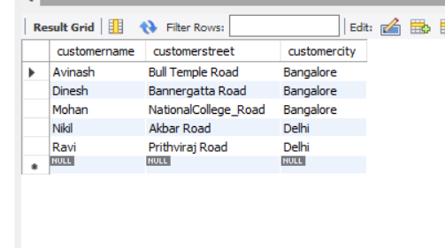

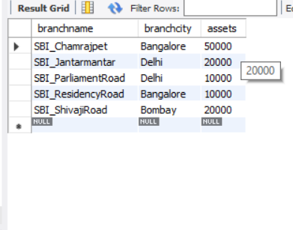

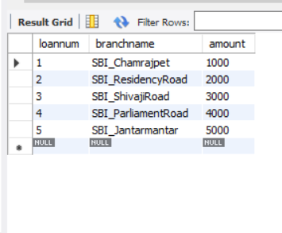

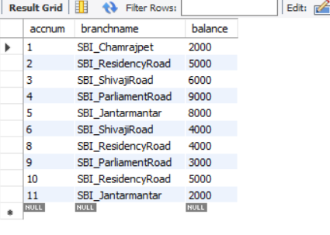

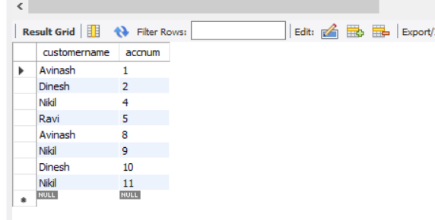

**QUERIES:**

**1.Find all the customers who have at least two accounts at the same branch (ex: “SBI_Residency_road”)**

**select depositer.customername**

**from Depositer , BankAccount**

**where BankAccount.accnum = depositer.accnum and BankAccount.branchname = 'SBI_ResidencyRoad'**

**group by depositer.customername having count(*) >= 2;**

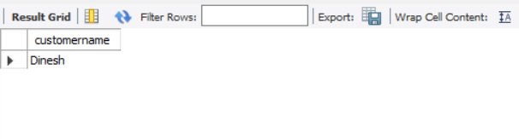

**2. Find all the customers who have an account at all the branches located in a specific city (ex: “delhi”)**

**select depositer.customername**

**from Depositer , BankAccount , Branch**

**where depositer.accnum=BankAccount.accnum and Branch.branchname=BankAccount.branchname and branch.branchcity='Delhi'**

**group by Depositer.customername**

**having count(distinct Branch.branchname)=(select count(branchname)**

**from Branch where branchcity='Delhi');**

